Victorian Marine and Coastal Council

Annual Report 2023–24



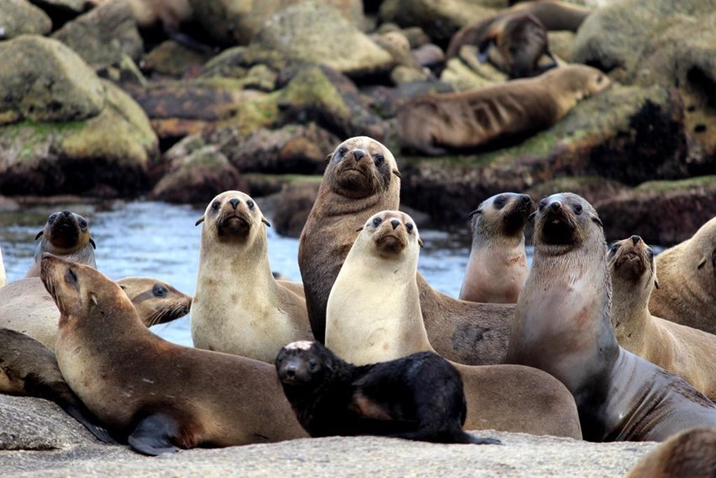

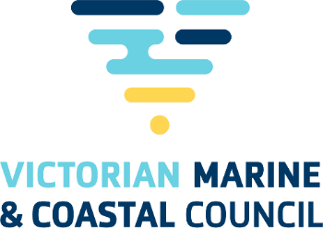

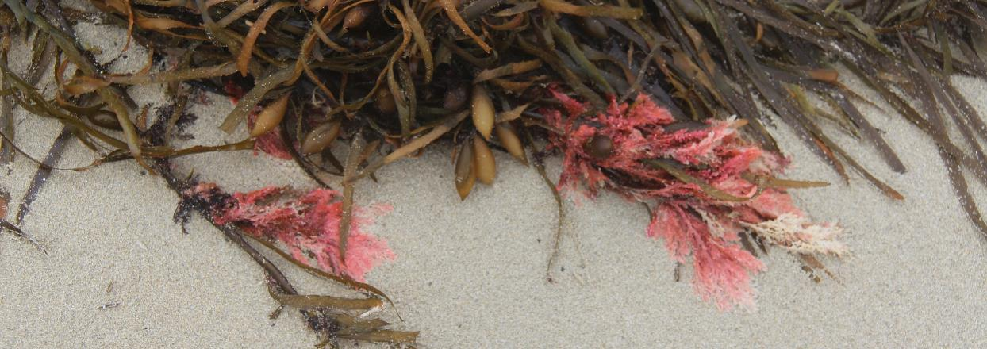

Prepared by the Victorian Marine & Coastal Council  
8 Nicholson Street, East Melbourne, Victoria 3002

October 2024

© The State of Victoria Department of Energy, Environment, and Climate Action Melbourne 2024

This work is licensed under a Creative Commons Attribution 3.0 Australia licence. You are free to re-use the work under that licence, on the condition that you credit the State of Victoria as author. The licence does not apply to any images, photographs or branding, including the Victorian Coat of Arms, the Victorian Government logo and the Victorian Marine and Coastal Council logo. To view a copy of this licence, visit <http://creativecommons.org/licenses/by/3.0/au/deed.en>

Accessibility

If you would like to receive this publication in an alternative format, please telephone DEECA Customer Service Centre 136 186, email customer.service@delwp.vic.gov.au, via the National Relay Service on 133 677   
www.relayservice.com.au. This document is also available on the internet at [www.marineandcoastalcouncil.vic.gov.au](http://www.marineandcoastalcouncil.vic.gov.au)

Disclaimer

This publication may be of assistance to you, but the State of Victoria and its employees do not guarantee that the publication is without flaw of any kind or is wholly appropriate for your particular purposes and therefore disclaims all liability for any error, loss or other consequence which may arise from you relying on any information in this publication.

Photo acknowledgements

Contact Victorian Marine & Coastal Council Secretariat for further information.



We acknowledge Victorian Traditional Owners and their Elders past and present as the Original Custodians of Victoria’s land and waters and commit to genuinely partnering   
with them and Victoria’s Aboriginal community to progress their aspirations.

Aboriginal flag Torres Strait Islander flag 

Contents

Responsible body declaration 4

Foreword 5

1 Year in review 6

1.1 Sixth year 6

1.2 Purpose and function 7

1.3 Advice to the Minister 7

1.4 Highlights/performance against functions 7

2. Governance and organisational structure 12

2.1 VMaCC membership 12

2.2 VMaCC Meetings 14

2.3 Representation on stakeholder reference groups 15

2.4 VMaCC sub-committees 15

2.5 Presentations received at VMaCC meetings 16

2.6 Submissions by VMaCC 17

2.7 VMaCC publications 17

2.8 Conferences and seminars 17

2.9 Statement of pecuniary Interests 17

2.10 Performance 17

2.11 Risk management 17

2.12 Occupational Health and Safety Policy 17

2.13 Employment and conduct principles 17

3. Workforce data 18

3.1 Workforce Data 18

3.2 Women, Youth and Indigenous Affairs 18

4. Other disclosures 18

4.1 Freedom of Information (FOI) 18

4.2 Making a request 18

4.3 Compliance with the *Public Interest Disclosures Act 2012* 19

4.4 Office-based environmental impacts 19

4.5 Statement of Availability of Other Information 19

4.6 Compliance with Data Vic Access policy 19

4.7 Overseas travel 19

5. VMaCC expenditure 20

5.1 Expenditure and financial management 20

5.2 Operating position 20

6. Abbreviations and Acronyms 21

# Responsible body declaration

In accordance with the Marine and Coastal Act 2018 I am pleased to present the Victorian Marine and Coastal Council Annual Report for the reporting period 1 July 2023 to 30 June 2024.

Signature Chair VMaCC

Anthony Boxshall PhD BSc GAICD

Chairperson, Marine and Coastal Council

14 October 2024

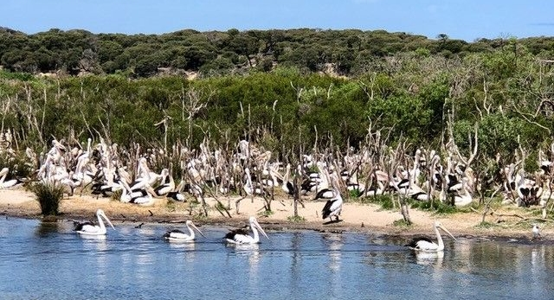

Pelicans in Gippsland (Marianne Atkinson)

# Foreword

The Victorian Marine and Coastal Council (VMaCC) was established under Section 16 of the Marine and Coastal Act 2018 and is the state’s peak advisory body on marine and coastal issues. It is served by eight members whose skills and expertise range across marine environments, coastal planning, physical sciences, ecological sciences, catchment management, cultural heritage, stakeholder engagement, governance, law and much more. Our purpose is to provide evidence and stakeholder-informed advice to enable leadership in the adaptive planning and management of Victoria’s marine waters and coastal areas.

***The vision for Council is a resilient and healthy marine and coastal environment, now and in the future.***

Since its inception Council has emphasised:

* the need for evidence-based research to inform planning and adaptation practice
* effective engagement with stakeholders through continuing consultation, active listening and direct reporting
* the importance of embedding Traditional Owner groups in policy and planning processes and partnerships
* identifying and prioritising current and emerging issues and opportunities to inform the development of an annual work plan
* Integrity, transparency and a culture of continuous improvement

Now that the state’s Marine and Coastal Policy, Strategy, and Management Plan Guidelines have been developed, Council has recognised that one of their greatest strengths lies in the ability to strategically influence and advocate at all levels and across a wide spectrum of networks. Council’s focus has shifted to supporting and monitoring effective application and implementation, whilst continuing to seek stakeholder feedback and encouraging the development and effective use of tools and processes.

The past year (and sixth term of Council) work on the launch and exposure of the report “*Economic Impacts from Sea Level Rise and Storm Surge in Victoria, Australia over the 21st century*” (the Kompas report) provided a major opportunity for Council to progress its coastal and marine reform agenda and to maintain and consolidate communications with stakeholders across the state in a two-way dialogue of information sharing.

The appointment of four new members in July 2023 and a permanently appointed Executive Officer provided the opportunity to review the effectiveness of current operations and to set the basis for a new cycle of business planning. This was a valuable exercise and allowed Council’s function to maintain balance and strategic focus from within the various adjustments occurring through government portfolio leads and subsequent Departmental restructure changes.

Council is proud of the following achievements of the past year:

* The launch in July 2023 of *“Economic Impacts from Sea Level Rise and Storm Surge in Victoria, Australia over the 21st century*”
* In response to this report, the call by VMaCC and Life Saving Victoria for the establishment of an independent taskforce to develop and promote a vision and operational blueprint to guide Victoria’s response to rising sea levels and related storm surge
* The updated [VMaCC Business Plan 2024–2026](https://www.marineandcoastalcouncil.vic.gov.au/__data/assets/pdf_file/0029/710894/2024-26-Victorian-Marine-and-Coastal-Council-Business-Plan_V0.5.pdf) and a renewed focus on advocacy and strategic implementation, building on the focus of the previous plan.
* A pre-planned, independent performance review of Council informed by past, continuing and new members which reviewed past performance, key achievements, and their implications for the work plan
* The appointment of new members of a high calibre with expertise in marine ecology and biology, climate change adaptation and governance. Thus, continuing the high-quality appointments to VMaCC.
* The invitation by, and ongoing discussions with, representatives of Traditional Owner groups along the coast to progress a partnership between VMaCC and a proposed Saltwater Council
* Improved communications with the Minister’s office brought about by renewed advocacy and networking

It has been a positive year for the Council building on valuable insights for improved practice. We look forward to further the rich conversations held with our coastal and marine stakeholders in the coming year and to the upcoming Marine and Coastal Awards event which provides an opportunity to showcase their achievements.

South Gippsland (Jennifer Fraser)

# 1 Year in review

## 

## Sixth year

The Victorian Marine and Coastal Council is established as an advisory body under the *Marine and Coastal Act 2018* to provide expert guidance and advice to the Minister on issues relating to Victoria’s marine and coastal environments.

The responsible Minister for the period was:

* from 1 July 2023 to 2 October 2023 Ingrid Stitt MP, Minister for Environment.
* From 2 October 2023 to 30 June 2024 Steve Dimopoulos MP, Minister for Environment.

|  |  |  |
| --- | --- | --- |
| Council Members | Member new or continuing | Period of appointment |
| Ms Marianne Atkinson | Continuing | 1 August 2021 – 31 July 2024 |
| Dr Anthony Boxshall (Chair) | Continuing | 1 August 2021 – 31 July 2024 |
| Dr Anna Grage | Continuing | 1 August 2021 – 31 July 2024 |
| Dr Rebecca McIntosh | New | 1 August 2023 – 31 July 2026 |
| Ms Mikaela Power | New | 1 August 2023 – 31 July 2026 |
| Professor Gerald Quinn | New | 1 August 2023 – 31 July 2026 |
| Ms Kylie Steel | New | 1 August 2023 – 31 July 2026 |
| Ms Jacquie White (Deputy Chair) | Continuing | 1 August 2021 – 31 July 2026 |
| Ms Jennifer Fraser | Outgoing | 1 August 2021 – 31 July 2024 |
| Dr Ian Knuckey | Outgoing | 1 August 2021 – 31 July 2024 |
| Emeritus Professor Alistar Robertson | Outgoing | 1 August 2021 – 31 July 2024 |
| Dr John Sherwood | Outgoing | 1 August 2021 – 31 July 2024 |

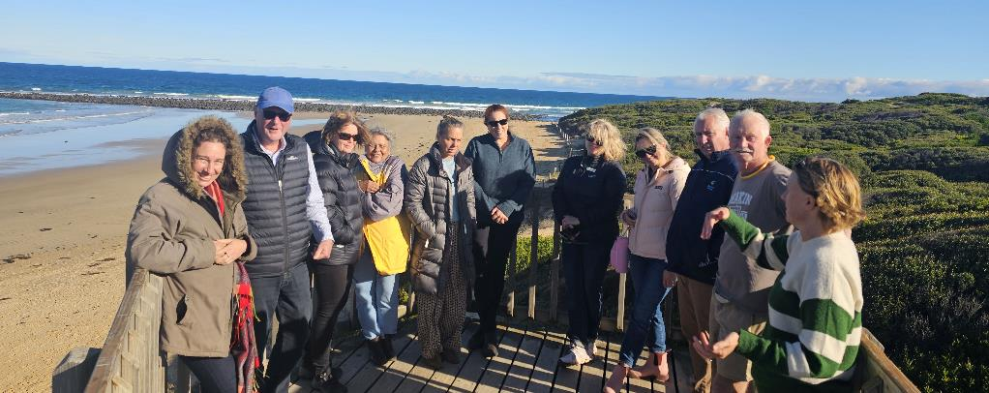

Figure 1: Site visit to Bancoora Surf Life Saving Club

## Purpose and function

Section 16 of the Act outlines VMaCC’s functions and accountabilities in relation to the Responsible Minister. Council’s purpose is to provide evidence-based and stakeholder informed advice for Ministers to enable leadership in the adaptive planning and management of Victoria’s marine waters and coastal areas.

Council uses its influence, expertise and convening powers to advocate for a healthy, dynamic and biodiverse marine and coastal environment that is valued in its own right, and that benefits the Victorian community, now and in the future.

Members continue with the successful exercise of their influence, expertise and strong stakeholder relationships to build collaborative and trusted networks. Most importantly we endeavour to synthesise and communicate a stakeholder ‘voice’.

## Advice to the Minister

In July 2023 the then Minister was briefed on the launch of the Economics Report (Kompas report) and approval was received for a launch of that report later that same month.

After a ministerial reshuffle in October 2023, VMaCC sought an early opportunity to brief the new minister, the Hon, Steve Dimopoulos, MP. This briefing was held in January 2024 and items for discussion included:

* an introduction to VMaCC (its members, function and role)
* the VMaCC Business Plan 2024 – 2026
* the Economics Report (Kompas report)
* an invitation to attend and present the Victorian Marine and Coastal Awards in the second half of 2024

The Minister expressed a keen interest in further briefings and will present the Marine and Coastal Awards in November 2024.

Indirect advice to the Minister occurred through advice to DEECA leadership covering several topics:

* Feedback on the draft Coastal and Marine Management Plan Guidelines (CMMPs)
* Contributions to the Coastal Erosion Advice Project
* Ongoing advice on the development of tools and guidance under the Act. These include:
  + Marine Spatial Planning Guidelines (MSP)
  + Coastal and Marine Management Plans (CMMPs)
  + Victoria’s Resilient Coast Guidelines
  + Regional Adaptation Strategic Partnerships (RaSPs)

## Highlights/performance against functions

### Traditional Owner partnerships

One of VMaCC’s major objectives is to progress the rights and aspirations of Traditional Owner groups and custodians for land and sea country and to enable their participation in marine and coastal planning, management and protection.

In this context, Council has continued to embed First Nations representation in its membership and has actively sought the participation of Traditional Owners and custodians across all its operations.

Additionally, Council was honoured to be approached by leaders of Victoria’s Traditional Owner groups on the coast with a proposal to form a partnership with a Saltwater Council, which would include representatives of all coastal Traditional Owner custodian groups.

Council views this approach as a measure of great trust and is very supportive of the proposal. Discussions will continue to be held with delegates from Traditional Owners to further progress this partnership.

### Research and evidence base

Another of VMaCC’s principal objectives relates to the need to consolidate latest science and stakeholder-informed evidence to support better decision-making.

##### The Kompas Report

In this regard, a major achievement was the publication in July 2023 of the Kompas report – formally titled, *Economic Impacts from Sea Level Rise and Storm Surge in Victoria, Australia over the 21st century*.

This study provides robust, evidence-based and costed advice to the Victorian Government and community to prepare for sea-level rise.

This report generated great interest both within the media and the wider marine and coastal community, and Council members actively communicated its findings at conferences and special briefings. The Chair has given a number of interviews to national, State, and regional outlets since the release of the report.

As a primary recommendation of the report, VMaCC and Life Saving Victoria have called for the establishment of an independent taskforce to develop and promote a vision and operational blueprint to guide Victoria’s response to rising sea levels and related storm surge.

##### The Expert Advisory Panel (EAP)

The Expert Advisory Panel comprises scientists and other experts representing a broad range of disciplines to provide a "catchment to shelf" perspective. The Panel provides independent, strategic, scientific advice to the Council on emerging marine and coastal issues and knowledge gaps.

In the context of changes in membership and key personnel and the competing demands of the Kompas Report, the EAP spent a short period in hiatus before regrouping to focus on a valuable review of its role and on planning priority projects.

The EAP and sub-committee are currently working on a longitudinal analysis of key trends over WAVE surveys 1-5 and the development of recommendations for survey 6. This work looks at what Victorians most value about the state’s marine and coastal environments and explores what and how different kinds of activities pose a threat to these environments, as well as attitudes towards key challenges including climate change, population growth and coastal development

### Stakeholder informed

VMaCC has continued to build its role in in enabling a stakeholder ‘voice’, bringing many different perspectives and roles in marine and coastal management to the discussion

This year Council continued its practice of travelling to different regional destinations to ensure comprehensive inclusion in discussions with rightsholders, stakeholders and communities. Valuable learnings came out of listening to the ‘on ground’ experiences of Victoria’s marine and coastal managers.

Council members were also very active in presenting at conferences and attending briefing meetings with communities of interest to share updates on climate change adaptation and the findings of the Kompas Report.

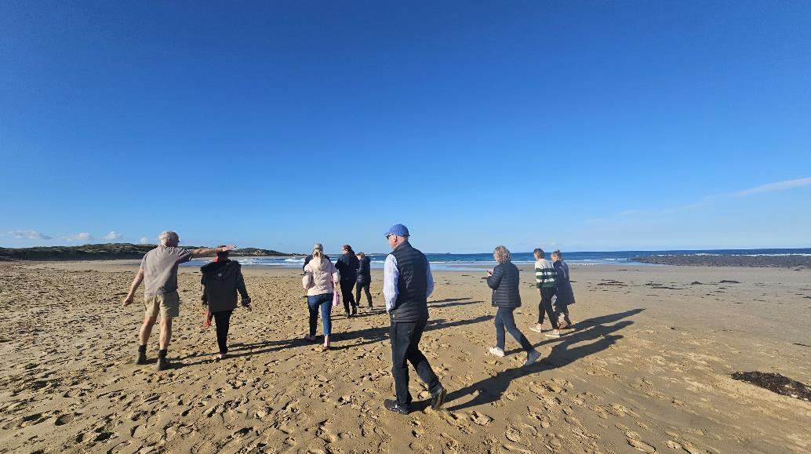

VMaCC Site Visit – Bancoora Beach (May 2024)

### Highlights against VMaCC functions

Section 16 of the Act includes 11 functions of VMaCC. These functions are outlined below including a high-level summary of deliverables against each from 1 July 2023 to 30 June 2024.

|  |  |
| --- | --- |
| Functions | Deliverable |
| *Function (a) and (b)*  Marine and Coastal Policy and Marine and Coastal Strategy development and implementation | VMaCC worked closely with DEECA in developing tools for the development and implementation of the Marine and Coastal Policy and Strategy. These tools include   * The Marine Spatial Planning Framework (MSP) * Coastal and Marine Management Plan (CMMP) Guidelines * Regional and Strategic partnerships (RaSps) and strategies for their monitoring and implementation |
| *Function (c)*  Provide advice to the Minister on significant decisions under the Act | VMaCC was proactive in ensuring good communications with the Minister’s office in times of organisational restructure and change.  Important topics raised with the Minister were:   * The Kompas Report and its recommendations * An overview of VMaCC’s members role and function * The 2024-2026 Business Plan and its priorities * The 2024 Marine and Coastal Awards |
| *Function (d)*  Matters requiring scientific research | The Kompas Report entitled *Economic Impacts from Sea Level Rise and Storm Surge in Victoria, Australia over the 21st century* was launched in July 2023 and Council members worked hard at its exposure in the ensuing months.  VMaCC members also maintained currency of their skills base through their involvement in several state and national science committees including:   * National Marine Science Committee (NMSC) * Senior Stakeholder Advisory Committee on Nature Based Coastal Defence * Office of the Commissioner for Environmental Sustainability (OCES) Stakeholder Reference Group * Integrated Marine Observing System – Victoria (VIC IMOS) |
| *Function (e)*  Provide advice on guidelines prepared under the Act | VMaCC provided advice on preparing the following draft guidelines:   * Coastal and Marine Management Plan guidelines * Victoria’s Resilient Coast guidelines |
| *Function (f) and (g)*  Request the Minister establish Regional and Strategic Partnerships (RASP) & provide advice to participants | VMaCC received updates and provided advice to DEECA regarding the proposed Cape to Cape RaSP.  The Minister did not seek VMaCC advice regarding the establishment of any other RaSPs, nor did VMaCC make any suggestions to Minister regarding further RaSPs during the year. |
| *Function (h)*  Provide input to the preparation of Environmental Management Plans under the Act | VMaCC will provide input into preparing Environmental Management Plans (EMP) as required. Currently the Port Phillip Bay EMP is the only EMP under the Act. VMaCC is a member of the Port Phillip Bay EMP Senior Agency Reference Group providing advice (as required) on the priorities and emerging issues and/or risks that may impact implementation. |
| *Function (i)*  Matters relating to or affecting the administration of the Act | Supporting the preparation of the Marine and Coastal Strategy as a key document to assist in the administration of the Act has been the focus for VMaCC over the past year.  In this year, VMaCC had no requirement to draw the Minister’s attention to any specific matters relating to, or affecting, the administration of the Act. |
| *Function (j)*  Carry out any other function conferred on VMaCC by or under the Act or any other Act | The Act is complemented by the Marine and Coastal Policy and the Marine and Coastal Strategy which identify a program of reforms and on-the-ground actions over the coming years.  The Policy and Strategy reflect the objectives and guiding principles set under the Act.  VMaCC has an oversight and advocacy role in ensuring these reforms and actions are carried out, and to effectively engage and enable Traditional Owner voices, stakeholders and the community. |
| (2) In performing its functions VMaCC must have regard to principles and objectives of the Act. | VMaCC’s vision is aligned with that of the Policy: *for a healthy marine and coastal environment now and, in the future, which is to be achieved by giving effect to the principles and objectives of the Act.*  The objectives of the Act relate to planning and management of the marine and coastal environment. They define rights and aspirations, and set measures and arrangements designed to ensure these are met. VMaCC always considers the principles and objectives of the Act in its decisions, activities and advice. |

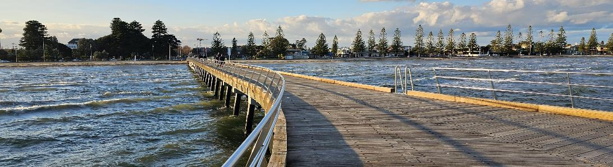

Altona Foreshore (Franzi Taylor)

### Presentations given, and workshop contributions, by VMaCC members and staff

VMaCC members and staff gave the following presentations and contributed to workshops and panel discussions shown in the table below.

|  |  |  |  |
| --- | --- | --- | --- |
| Presenter | Presented to | Topic | Date |
| Dr Boxshall | Victorian Planning & Environmental Law Association (VPELA) conference, Lorne | Vic Resilient Coast - Collaborative Working Group session #7 and program launch | 31 August 2023 |
| Dr Boxshall | Victorian Geospatial Conference and Geospatial Excellence Awards, Melbourne | *Economic Impacts from Sea Level Rise and Storm Surge in Victoria, Australia over the 21st century* | 14 September 2023 |
| Dr Boxshall & Dr Anna Grage | Joint National Coast to Coast and NSW Coastal Conference | Using economic information in coastal decision-making: an overview of the Kompas Report | 31 October 2023 |
| Dr Boxshall | Infrastructure Victoria Webinar | Understanding Sea Level Rise (SLR) and the implications for infrastructure and land use planning | 29 November 2023 |
| Dr Boxshall | Victoria’s Resilient Coast – Adapting for 2100+ Community of Practice | Using economic information in coastal decision-making: an overview of the Kompas Report | 13 December 2023 |
| Dr Anna Grage | Mornington Peninsula Shire Councillor Briefing – Our Coast, Our Future | Using economic information in coastal decision-making: an overview of the Kompas Report | 19 December 2023 |
| Ms Jacquie White | Victorian Environmental Assessment Council (VEAC) | Introduction to VMaCC and informal discussion around opportunities for cross-collaboration. | 13 March 2024 |
| Dr Boxshall | Adaptation Directors Committee | VMaCC Update: Economic Impacts of Sea Level Rise and Storm Surge in Victoria | 30 May 2024 |
| Ms Jacquie White | Australian Coastal Councils Association Conference | Economic Impacts from Sea Level Rise and Storm Surge in Victoria | 30 May 2024 |

### General Business activities

VMaCC business activities involved:

* advising and meeting with the office of both the former and the current Minister for Environment
* engaging with Traditional Owners to support and enable a Traditional Owner voice in VMaCC business and to progress partnership proposals
* meeting with rightsholders, stakeholders and partners through discussions, fora, and participating in working groups
* reviewing performance to inform the development of the new 2024 – 2026 VMaCC Business Plan
* progressing and finalising VMaCC priority projects including the Kompas report together with preparation of a comprehensive summary report that includes VMaCC recommendations.
* providing feedback to DEECA and lead agencies on preparing and developing the following draft Guidelines:
* Coastal and Marine Management Plan guidelines especially in relation to effective monitoring
* Victoria’s Resilient Coast guidelines
* Marine Spatial Planning Guidelines and planning areas

### 1.5.3 VMaCC Business Plan

VMaCC developed its Strategic Business Plan 2024-26 to provide a vision and strategic direction for future VMaCC activities.

Now that the Marine and Coastal Policy and Strategy have been finalised there has been a shift in Council’s focus to supporting and monitoring effective application and implementation.

Priorities outlined in the Business Plan continue to reflect the functions of VMaCC as outlined in the Act and Council will continue to seek stakeholder feedback and to focus on the evolving use of tools and processes (MSPs; CMMPs and RaSPs).

# Governance and organisational structure

VMaCC is resourced with a budget and Secretariat support through DEECA. On 30 June 2024 VMaCC was supported by 2 staff (1.5 full time equivalent).

Figure 1: Victorian Marine and Coastal Council Secretariat Organisational Structure

VMaCC’s office is located at 8 Nicholson Street, East Melbourne Victoria 3002.

The postal address for VMaCC is PO Box 500, East Melbourne Victoria 8002.

Telephone: 9637 8893

Email: [vmacc@delwp.vic.gov.au](mailto:vmacc@delwp.vic.gov.au)

Website: [www.marineandcoastalcoauncil.vic.gov.au](http://www.marineandcoastalcoauncil.vic.gov.au)

## VMaCC membership

Members of VMaCC were appointed on 1 August 2021 to 31 July 2024 (A. Boxshall, M. Atkinson, A. Grage, J. White) and 1 August 2024 to 31 July 2026 (R.McIntosh, M.Powell,   
G.Quinn and K. Steel). Four outgoing members (Ms Jennifer Fraser, Emeritus Prof. Alistar Robertson, Dr. Ian Knuckey and Dr. John Sherwood) completed their appointments on 31 July 2023. Their biographies are featured in previous annual reports.

Appointments to VMaCC are made under the provisions of the *Marine and Coastal Act 2018* by the Minister for Environment.

Both professional experience and capacity in networking and stakeholder engagement are key considerations for appointment to VMaCC.

As a result, VMaCC boasts a high calibre membership whose expertise covers a broad range of marine and coastal disciplines. This expertise, combined with stakeholder-informed evidence, provides a base for advice to the Ministers responsible for Victoria’s marine and coastal environments. Brief biographies of current VMaCC members follow.

Dr Anthony Boxshall (Chairperson)is a marine ecologist who has worked in Australia and the USA across Government, academia and private industry. He is the Founder and Principal of Science into Action Pty Ltd, a science impact company turning great science into greater actions. He is a Board Director of Parks Victoria and was the valedictory Chair of the Victorian Coastal Council. A former National President of the Australian Marine Sciences Association (AMSA – the largest learned society for professional marine scientists in Australia), he has worked at UC Santa Cruz USA, Deakin University, and has been on several innovation Boards. A current Melbourne Enterprise Fellow in the School of Biosciences at the University of Melbourne, he ran the Science area at the Environment Protection Authority (EPA) in Victoria for nearly a decade.  
As a hobby, Anthony has communicated the wonders of the marine and coastal environment to a broad audience through the award-winning “Radio Marinara” on 3RRR-FM in Melbourne for more than 27 years. He is a dad to 4 children who continually amaze, inspire, frustrate and leave him in awe of the potential of the future and hence more determined to leave a positive coastal and marine legacy.

Ms Jacquie White (Deputy Chair) has over 20 years’ experience working in the environment sector across coastal management, catchment management, integrated water management, community and stakeholder engagement, organisational change and capacity building, and social research and evaluation. Jacquie recently commenced a new role with Melbourne Water as Healthy Waters Strategy Coordinator. She also runs a consultancy providing event management and stakeholder engagement services.

Jacquie's previous professional roles include General Manager of the Environment Institute of Australia and New Zealand, Manager Community Programs at Melbourne Water, Director at the Office of Living Victoria, and Manager of Organisational Transformation with the Country Fire Authority.

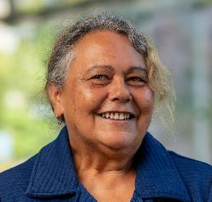Ms Marianne Atkinson’s professional working history includes the areas of Government, Human Services, Education & Training, Family Violence Policy, Systems & Reform, Aboriginal Affairs, and community organisations. Marianne Is expert in developing policy and strategy, providing advice to government, regional and strategic partnerships, and working with community members as well as all levels of professionals to codesign and develop effective processes for the evaluation and validation of programs, systems, and structures. She has broad experience leading, coordinating and liaising with community groups and preparing and facilitating state-wide strategies in response to community needs. Her work is geared towards improving outcomes to adapt new practices and systems of change to progress ideas and transform thoughts into action driven solutions. Ms Atkinson is currently employed at RMIT University Melbourne in a part-time casual role as VE Tutor Diploma of Community Services. Her fields of study include Business, Business Analytics, Education, and Data Analysis. She is currently the Co-Chairperson Aboriginal Torres Strait Islander Advisory Group (National representatives), Australian War Memorial and the Gunaikurnai Traditional Owner Land Management Board.

Dr Rebecca McIntosh is a Marine Scientist at Phillip Island Nature Parks. She has over 20 years’ experience specialising in marine mammals and avian ecology, anthropogenic change, wildlife monitoring and threatened species management. Dr McIntosh is a former Senior Researcher at South Australian Research and Development Institute. She has worked on the ecology and demography of marine predators for over 20 years, with a focus on Australian seals. She holds a Bachelor of Science and Doctor of Philosophy in population biology. Dr McIntosh demonstrates a comprehensive understanding of climate change adaptation, the coastal and marine industry, conservation, marine science and policy, risk management and community and stakeholder engagement.

Dr Anna Grage has a background in marine environmental law and planning, and statutory (urban/environmental) planning. She has a Bachelor of Laws, a Bachelor of Planning and Design (Hons), and a PhD (University of Wollongong) that focuses on Australian legal frameworks for marine environmental impact assessment. Anna has worked as a lecturer at the Australian Maritime College/University of Tasmania, teaching in the areas of international ocean governance, environmental advocacy, and marine environmental and fisheries law and policy.

Anna has worked in Victoria and Western Australia as a statutory planner for local government, and as a solicitor in the areas of planning and environmental law; with her most recent local government role being with Mornington Peninsula Shire. Anna is currently a Visiting Research Fellow at the University of Adelaide, Principal Consultant of Earth-Sea Planning, and a volunteer for the Sea Search (Parks Victoria) program/Friends of Mushroom Reef Marine Sanctuary, and the Country Fire Authority.

Ms Mikaela Power is in an experienced senior leader in the public and private sectors in Gippsland, Melbourne and overseas. She is an Associate Director Partnerships and Growth at Federation University and a former senior executive at Gippsland TAFE. Ms Power was a Baw Baw Shire Councillor from 2012 to 2020, and Mayor in 2019 and is a former Deputy Chair of the Periurban Group of Rural Councils. Ms Power brings skills and experience in local government, town planning, public sector governance and administration, an understanding of the law, policy and obligations in relation to Traditional Owners, community and stakeholder engagement and strategic planning. She is Chair of the West Gippsland Catchment Management Authority.

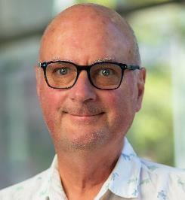Professor Gerald Quinn is former Head of the Warrnambool Campus of Deakin University (2012–2015) and former Chair in Marine Biology, School of Life and Environmental Sciences, retiring in 2020. He is currently an honorary professor at Deakin University and has served on several statutory bodies, advisory committees and government public entities.  He has extensive research experience in coastal marine ecology, freshwater ecosystems and the effects of flow change on rivers and wetlands. He is a current board member at Glenelg Hopkins Catchment Management Authority. Professor Quinn holds Bachelor of Science in Zoology, a Doctor of Philosophy in Marine Biology and has completed the Australian Institute of Company Directors Course. Professor Quinn demonstrates a comprehensive understanding of climate change adaptation, the coastal and marine industry, conservation, marine science and policy, risk management, community and stakeholder engagement, strategic thinking and planning.

Ms Kylie Steel is the founder and director of SCB Consult, a consultancy specialising in climate change, bushfire science and emergency management. She has been a board director on Southern Rural Water since 2019, and on Barwon Health Foundation since 2017.  She was a board member and Deputy Chair on the Great Ocean Road Coast Committee from 2013 to 2020. Ms Steel holds qualifications in business, company directorship, bushfire planning and management and science.  Ms Steel demonstrates a comprehensive understanding of climate change adaptation, the coastal and marine industry, conservation, local government, town planning, marine science and policy, public sector governance and administration, risk management, community and stakeholder engagement and strategic planning.

## 2.2 VMaCC Meetings

In the reporting period, VMaCC held 7 meetings as follows:

* 17 July 2023
* 21 August 2023
* 16 – 17 October 2023
* 27 November 2023
* 19 February 2024
* 8 April 2024
* 6 May 2024

Member attendance for VMaCC’s 7 business meetings in 2023-24 are as follows:

* + Dr Anthony Boxshall 6
  + Ms Marianne Atkinson 6
  + Dr Anna Grage 7
  + Dr Rebecca McIntosh 5
  + Ms Mikaela Power 5
  + Professor Gerry Quinn 6
  + Ms Kylie Steel 6
  + Ms Jacquie White 7

Four outgoing members (Ms Jennifer Fraser, Emeritus Prof. Alistar Robertson, Dr. Ian Knuckey and Dr. John Sherwood) also attended the July meeting.

## 2.3 Representation on stakeholder reference groups

VMaCC membership on stakeholder reference groups in the 2023-24 financial year was as follows:

* Commissioner for Environmental Sustainability Reference Group (OCES) – Dr Anthony Boxshall
* National Marine Science Committee (NMSC) – Dr Anthony Boxshall (until 2024 when Victorian representation passed to DEECA)
* Senior Stakeholder Advisory Committee on Nature Based Coastal Defence – Anna Grage

## 2.4 VMaCC sub-committees

VMaCC members were involved in the following VMaCC sub-committees to guide and progress strategic projects and activities:

* Communications and Engagement Sub-Committee (Chair: Jacquie White; Members: Anthony Boxshall, Mikaela Power, Marianne Atkinson, Kylie Steel).
* Expert Advisory Panel Sub-Committee (Chair: Gerald Quinn; Members: Anna Grage, Rebecca McIntosh). The EAP has 29 independent members – more information about each member can be found on [VMaCC’s website](https://www.marineandcoastalcouncil.vic.gov.au/about-us/expert-advisory-panel)).

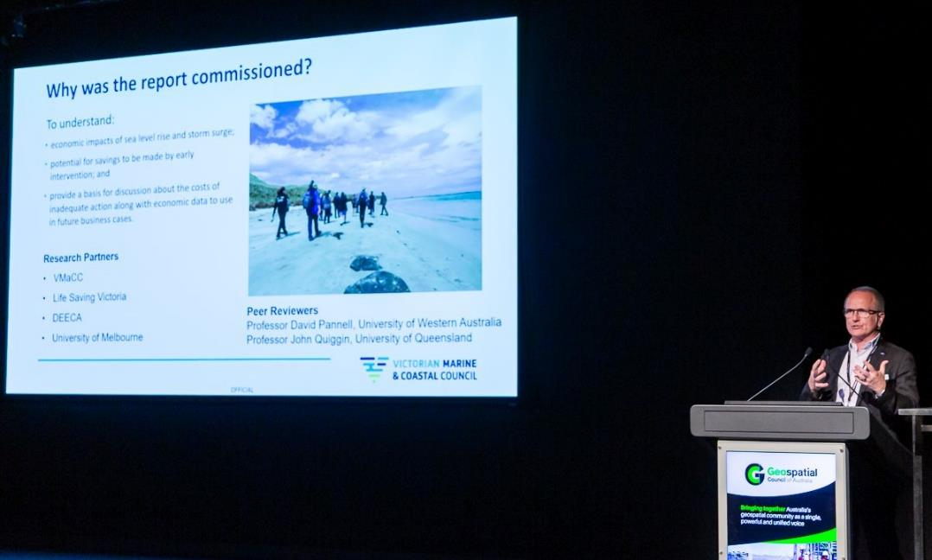

Dr Anthony Boxshall, Chair VMaCC presenting at the 2023 Victorian Geospatial Conference (October 2023)

## Presentations received at VMaCC meetings

VMaCC received the following presentations at its meetings in 2023-24:

|  |  |  |
| --- | --- | --- |
| Presenter | Topic | Date |
| Will Guthrie, Director, Marine, Coast & Land Policy  Elisa Zavadil, Manager Regional & Coastal Adaptation & Planning, DEECA  Rebecca. Price, Principal Policy Officer, Policy & Strategy Unit, DEECA | Coastal Erosion Advice Project | 17 July 2023 |
| Amber Perry, Manager, Waterway Policy, Corangamite Catchment Management Authority (CO CMA) | The Victorian Healthy Waterway Management strategy | 17 July 2023 |
| Will Guthrie, Director, Marine, Coast & Land Policy, DEECA  Nicola Waldron, Manager, Policy & Strategy Unit, DEECA | Marine and Coastal Strategy and Policy – an overview and DEECA priorities | 16 October 2023 |
| Committees of Management – Bellarine Bayside CoM (Bruce Elliot, CEO and Melanie Rogers); Barwon Coast CoM (Paul Gengelle, Acting CEO and Sandra Gatehouse, Chair) and Great Ocean Road Coasts and Parks Authority GORCAPA (Cath Olive, Director Infrastructure & Planning and Lisa Mills, Director Environment & Coastal Operations) | Challenges and opportunities at the local level. | 27 November 2023 |
| Will Guthrie, Director, Marine, Coast & Land Policy, DEECA | Policy & Strategy Unit update | 27 November 2023 |
| Emeritus Professor Alistar Robertson, former EAP Chair | The EAP and next steps | 27 November 2023 |
| Associate Professor Daniel Ierodiaconou, Deakin University  Will Guthrie, Director, Marine, Coast & Land Policy  Nicola Waldron, Manager, Policy & Strategy Unit, DEECA  Polly Matthews, Manager Community & Partnership Programs, DEECA | Coast Research Infrastructure (Coast RI) and Vic IMOS | 19 February 2024 |
| Rebecca Price, Principal Policy Officer, Policy & Strategy Unit, DEECA  (W. Guthrie and N. Waldron also attended) | Marine and Coastal strategy MERI Update | 19 February 2024 |
| Elisa Zavadil, Manager Regional & Coastal Adaptation & Planning, DEECA  Polly Matthews, Manager Community & Partnership Programs, DEECA | DEECA Briefing on Port Phillip Bay Coastal Hazard Assessment | 19 February 2024 |
| Will Guthrie, Director, Marine, Coast & Land Policy DEECA  Nicola Waldron, Manager, Policy & Strategy Unit, DEECA  Rachel Manassa, Senior Policy Officer, Policy & Strategy Unit, DEECA | Marine Spatial Planning (MSP) Update | 8 April 2024 |
| Daniel Miller, CEO Gunaikurnai Land and Waters Aboriginal Corporation  John Clarke, General Manager, Cultural Landscapes Eastern Maar  Matthew Chatterton, Warre (Sea) and Coastal Project Officer Wadawurrung TOAC | Overview of the proposed Saltwater Council | 6 May 2024 |
| Will Guthrie, Director, Marine, Coast & Land Policy | DEECA Executive Update | 6 May 2024 |

Tarwin South Beach (Kate Dickenson)

## Submissions by VMaCC

In June 2024, VMaCC made a submission to the Victorian Government’s *Inquiry into Climate Change Resilience.*

In this submission, emphasis was placed on the importance of a sea level planning benchmark as an essential tool for setting adaptation responses and on the need for a planning and decision pathway.

The submission highlighted the work of the Kompas Report and the recommendation for an ‘*independent taskforce…to be established to develop and promote a vision for, and operational blueprint to guide, Victoria’s response to the economy-wide consequences of rising sea levels and storm surge.’*

## VMaCC publications

The Kompas report (both full and in general summary) were published in July 2023. These reports are available on the VMaCC website as:

* [Economic Impacts from Sea Level Rise and Storm Surge in Victoria, Australia over the 21st century by Kompas, T. et al (2022).;](https://www.marineandcoastalcouncil.vic.gov.au/__data/assets/pdf_file/0030/665652/a1420184d6623d94a7f338f861671b6c68af15d5.pdf) and
* [A general summary of the report Economic Impacts from Sea Level Rise and Storm Surge in Victoria, Australia over the 21st century by Kompas, T. et al.](https://www.marineandcoastalcouncil.vic.gov.au/__data/assets/pdf_file/0036/665649/General-Summary-of-the-Kompas-Report-Economic-Impacts-from-SLR-and-SS-19072023.pdf)

## Conferences and seminars

Dr Boxshall, Dr Anna Grage and Ms Marianne Atkinson attended the 2023 Joint National Coast to Coast and NSW Coastal Conference from 30 October to 3 November 2023.

Ms Jacquie White, Dr Anna Grage and Ms Kylie Steel attended a Coastal Roundtable at Safety Beach Sailing Club on 15 March 2024.

Ms Jacquie White and Ms Marianne Atkinson attended the 2024 Australian Coastal Councils Conference from 29 to 31 May 2024.

## Statement of pecuniary Interests

All members of VMaCC and the Executive Officer have completed declarations of pecuniary interest for the current reporting period including details of shares held by members.

## 2.10 Performance

VMaCC completed an independent governance and performance review in the first quarter of 2023-24. This review was delayed from its original timing late in the COVID-19 pandemic period.

## 2.11 Risk management

While VMaCC examines the risks associated with the delivery of its work functions and objectives on an ongoing basis, it relies on DEECA’s risk management framework and internal audit of financial and other administrative systems used by VMaCC’s Secretariat as outlined in the DEECA Annual Report.

## 2.12 Occupational Health and Safety Policy

Operations are managed in accordance with DEECA procedures and guidelines for occupational health and safety, industrial relations, and related issues as outlined in the DEECA Annual Report.

## 2.13 Employment and conduct principles

The VMaCC uses DEECA’s employment processes. VMaCC and DEECA are committed to applying merit and equity principles when appointing staff. The selection processes ensure applicants are assessed and evaluated fairly and equitably based on the key selection criteria and other accountabilities without discrimination. Employees have been correctly classified in workforce data collections.

Consistent with requirements of the Public Administration Act 2004, VMaCC has adopted a range of policies designed to promote good governance in all its decision making and operations. These policies comprise: Code of Conduct; Conflict of Interest; Dispute Resolution; Gifts, Benefits and Hospitality; Meetings and Decision Making; and Performance Assessment. All of these policies are available online at the [VMaCC](https://www.marineandcoastalcouncil.vic.gov.au/about-us/about-vmacc))website.

# 3. **Workforce data**

Lorne Foreshore

## 

## 3.1 Workforce Data

On 30 June 2024 VMaCC was supported by two staff (1.4 full time equivalent). Across the year, the proportion of women employed was 100 per cent. These staff are employed by DEECA and are included in DEECA’s workforce data in the DEECA annual report.

## 3.2 Women, Youth and Indigenous Affairs

VMaCC is committed to involving Victoria’s community, including women, youth and Aboriginal Victorians in the planning, management and

enjoyment of the coast. The Act identifies actions to implement indigenous cultural outcomes and to improve communications with Aboriginal communities in coastal areas. VMaCC’s Business Plan includes actions to strengthen community involvement in coastal planning and management and VMaCC operates in an environment that ensures equity of processes and participation by rights’ holders and stakeholders.

# 4. Other disclosures

## 

## 4.1 Freedom of Information (FOI)

The Freedom of Information Act 1982 (FOI Act) allows the public a right of access to documents held by VMaCC. The purpose of the FOI Act is to extend as far as possible the right of the community to access information held by government departments, local councils, Ministers and other bodies subject to the FOI Act.

An applicant has a right to apply for access to documents held by VMaCC. This comprises documents both created by VMaCC or supplied to VMaCC by an external organisation or individual, and may also include maps, films, microfiche, photographs, computer printouts, computer discs, tape recordings and videotapes.

The FOI Act allows VMaCC to refuse access, either fully or partially, to certain documents or information. Examples of documents that may not be accessed include Cabinet documents; some internal working documents; law enforcement documents; documents covered by legal professional privilege, such as legal advice; personal information about other people; and information provided to VMaCC in-confidence.

The FOI Act has been amended to reduce processing time for requests received to 30 days. However, when external consultation is required the processing time automatically reverts to 45 days. Processing time may also be extended by periods of 30 days, in consultation with the applicant. With the applicant’s agreement this may occur a number of times.

If an applicant is not satisfied by a decision made by DEECA, under section 49A of the FOI Act, they have the right to seek a review by the Office of the Victorian Information Commissioner within 28 days of receiving a decision letter.

## 4.2 Making a request

VMaCC operates in accordance with FOI procedures established through DEECA. No FOI requests were made to VMaCC in 2023-24.

VMaCC has determined that DEECA is its authorised officer. FOI requests can be lodged online at https://ovic.vic.gov.au. An application fee of $32.70 applies. Access charges may also be payable if the document pool is large, and the search for material is time consuming. Access to documents can also be obtained by writing to the Department’s Freedom of Information Unit, as detailed in section 17 of the FOI Act:

Manager FOI

Department of Energy, Environment and Climate Action

PO Box 500 East Melbourne Victoria 3002

Email: [foi.unit@delwp.vic.gov.au](mailto:foi.unit@delwp.vic.gov.au)

Phone: (03) 7022 6530.

Further information regarding the operation and scope of FOI can be obtained from the Act; regulations made under the Act; and Freedom of Information – Office of the Victorian Information Commissioner (https://ovic.vic.gov.au)

## 4.3 Compliance with the *Public Interest Disclosures Act 2012*

The Public Interest Disclosures Act 2012 (PID Act) enables people to make a disclosure about corrupt or improper conduct by a public officer or a public body. VMaCC is a public body for the purposes of the PID Act.

What is a public interest disclosure?

A public interest disclosure is a complaint of corrupt or improper conduct or detrimental action by a public officer or a public body.

‘Improper or corrupt conduct’ involves substantial mismanagement of public resources, risk to public health or safety or the environment, or corruption.

‘Detrimental action’ is action taken against a person in reprisal for making a public interest disclosure.

How do I make a public interest disclosure?

You can make a public interest disclosure about VMaCC or its board members, officers or employees by contacting IBAC (details below).

VMaCC is not able to receive public interest disclosures.

VMaCC has established procedures for the protection of persons from detrimental action in reprisal for making a public interest disclosure about VMaCC, its members, officers or employees. You can access VMaCC’s procedures on its website at:

www.marineandcoastalcouncil.vic.gov.au/about-us/about-vmacc.

Independent Broad-Based Anti-Corruption Commission (IBAC) Victoria

Address: Level 1, North Tower, 459 Collins Street, Melbourne Victoria 3000.

Mail: IBAC, GPO Box 24234, Melbourne Victoria 3001

Internet: www.ibac.vic.gov.au

Phone: 1300 735 135

Email: See the website above for the secure email disclosure process, which also provides for anonymous disclosures.

## 4.4 Office-based environmental impacts

VMaCC makes use of DEECA offices and facilities to perform its functions and the reporting requirement of the office is met by DEECA. The VMaCC Secretariat participates fully in a range of environmental programs operating within DEECA.

## 4.5 Statement of Availability of Other Information

Other information held at VMaCC’s office is available on request, subject to the FOI Act.

## 4.6 Compliance with Data Vic Access policy

Consistent with the Victorian Government’s DataVic Access policy, VMaCC intends that data tables which it may produce in the future will be available at:

<http://data.vic.gov.au/> in machine readable format.

## 4.7 Overseas travel

There was no overseas travel by VMaCC members for VMaCC purposes in 2023-24.

# 

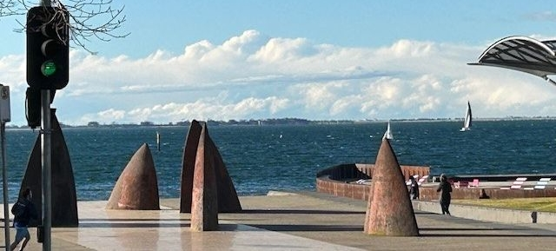

Figure 2: Geelong Foreshore

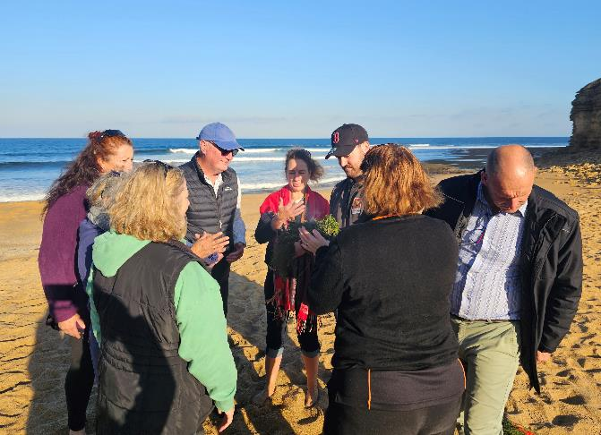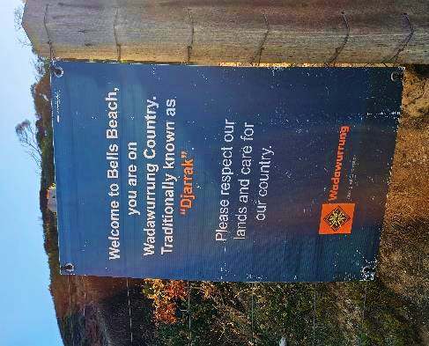

Sea Country Walk and Talk with Wadawurrung Traditional Owners Aboriginal Corporation (Djarrak, May 2024)

# 5. VMaCC expenditure

## 

## 5.1 Expenditure and financial management

VMaCC’s operating budget is provided within the budget of DEECA. Financial operations of VMaCC have not been separately audited. Audited statements are incorporated into the overall financial statements of the DEECA Annual Report for the year ended 30 June 2024. VMaCC is not required to retain a separate audit committee.

DEECA undertakes an annual assessment of financial management compliance with all applicable requirements in the Financial Management Act 1994, Standing Directions and Instructions. This includes the financial management of VMaCC’s activities. DEECA also periodically audits this compliance.

The following table shows the operating expenditure of VMaCC for the 2023-24 financial year (excluding salaries and agency staff costs) and provides a comparison with the previous year.

## 5.2 Operating position

Summary of Financial Results of the Year

|  |  |
| --- | --- |
| Financial Year | VMaCC operations* |
| 2023-24 | $154,614 |
| 2022-23 | $122,533.2 |

* Includes all members’ sitting fees, reimbursements, payroll tax, superannuation contribution, WorkCover levy, secretariat expenses, training, and items such as annual report, consultants and events.

### Consultancy expenditure

VMaCC expended $32,700 during the 2023-24 on consultancy projects.

### 5.2.2 Government advertising

Nil

VMaCC with PV rangers at Anglesea cliffs (Franzi Taylor)

# 6. Abbreviations and Acronyms

CMMP Coastal and Marinel Management Plan

DEECA Department of Energy, Environment and Climate Action

EAP Expert Advisory Panel

FOI Freedom of Information

LSV Life Saving Victoria

OCES Office for the Commissioner of Environmental Sustainability

MERI Monitoring, Evaluation, Reporting and Improvement

MSP Marine Spatial Planning Framework

NMSC National Marine Science Committee

PPB EMP Port Phillip Bay Environmental Management Plan

RaSP Regional and Strategic Partnership

**SLR** Sea Level Rise

VIC IMOS Victoria Integrated Marine Observing System

VMaCC Victorian Marine and Coastal Council

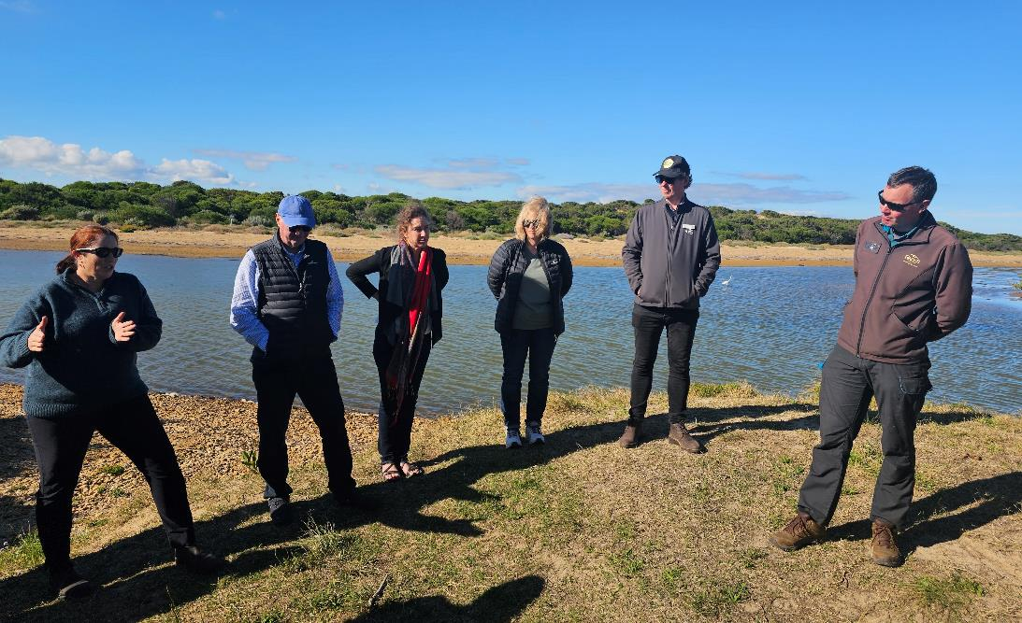

VMaCC Site Visit - Thompson Creek Estuary Opening (May 2024)